LAB PROGRAM 6A
a) WAP to Implement Single Link List with following operations: Sort the linked list,
Reverse the linked list, Concatenation of two linked lists.
#include <stdio.h>
#include <stdlib.h>
struct Node {
int data;
struct Node *next;
};
struct Node* createNode(int data) {
struct Node* newNode = (struct Node*)malloc(sizeof(struct Node));
newNode->data = data;
newNode->next = NULL;
return newNode;
}
void insertEnd(struct Node** head, int data) {
struct Node* newNode = createNode(data);
if (*head == NULL) {
*head = newNode;
return;
}
struct Node* temp = *head;
while (temp->next != NULL)
temp = temp->next;
temp->next = newNode;
}
void display(struct Node* head) {
struct Node* temp = head;
while (temp != NULL) {
printf("%d -> ", temp->data);
temp = temp->next;
}
printf("NULL\n");
}
void sortList(struct Node* head) {
struct Node *i, *j;
int temp;
for (i = head; i != NULL; i = i->next) {
for (j = i->next; j != NULL; j = j->next) {
if (i->data > j->data) {
temp = i->data;
i->data = j->data;
j->data = temp;
}
}
}
}
void reverseList(struct Node** head) {
struct Node *prev = NULL, *curr = *head, *next = NULL;
while (curr != NULL) {
next = curr->next;
curr->next = prev;
prev = curr;
curr = next;
}
*head = prev;
}
struct Node* concatenate(struct Node* list1, struct Node* list2) {
if (list1 == NULL) return list2;
struct Node* temp = list1;
while (temp->next != NULL)
temp = temp->next;
temp->next = list2;
return list1;
}
int main() {
struct Node *list1 = NULL, *list2 = NULL;
int choice, val;
while (1) {
printf("\n--- MENU ---\n");
printf("1. Insert in List1\n2. Insert in List2\n3. Display List1\n4. Display List2\n");
printf("5. Sort List1\n6. Reverse List1\n7. Concatenate List1 & List2\n8. Exit\n");
printf("Enter choice: ");
scanf("%d", &choice);

switch (choice) {
case 1:
printf("Enter value: ");
scanf("%d", &val);
insertEnd(&list1, val);
break;
case 2:
printf("Enter value: ");
scanf("%d", &val);
insertEnd(&list2, val);
break;
case 3:
display(list1);
break;
case 4:
display(list2);
break;
case 5:
sortList(list1);
printf("List1 Sorted.\n");
break;
case 6:
reverseList(&list1);
printf("List1 Reversed.\n");
break;
case 7:
list1 = concatenate(list1, list2);
printf("Concatenated List: ");
display(list1);
break;
case 8:
exit(0);
default:
printf("invalid choice");
}
}
return 0;
}

OUTPUT:
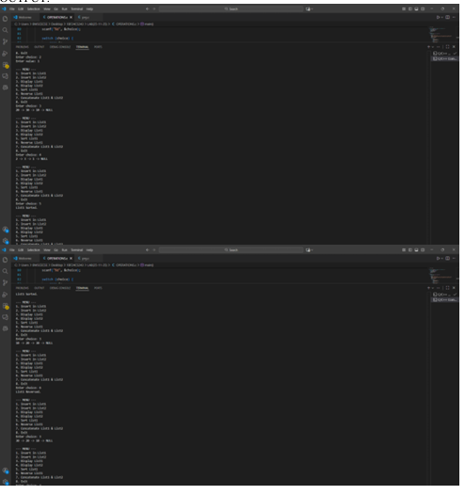

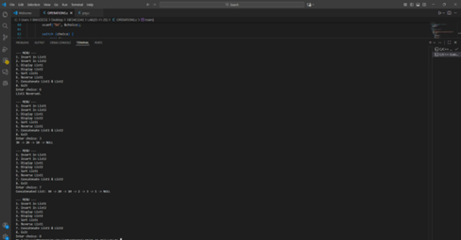

6 b WAP to Implement Single Link List to simulate Stack & Queue Operations.
#include <stdio.h>
#include <stdlib.h>
struct Node {
int data;
struct Node *next;
};
struct Node* createNode(int data) {
struct Node* newNode = (struct Node*)malloc(sizeof(struct Node));
newNode->data = data;
newNode->next = NULL;
return newNode;
}
// Stack operations (LIFO)
void push(struct Node** top, int data) {
struct Node* newNode = createNode(data);
newNode->next = *top;
*top = newNode;
}
void pop(struct Node** top) {
if (*top == NULL) {
printf("Stack Underflow!\n");
return;
}
struct Node* temp = *top;
printf("Popped: %d\n", temp->data);
*top = temp->next;
free(temp);
}
// Queue operations (FIFO)
void enqueue(struct Node** front, struct Node** rear, int data) {
struct Node* newNode = createNode(data);
if (*rear == NULL) {
*front = *rear = newNode;
return;
}
(*rear)->next = newNode;
*rear = newNode;
}
void dequeue(struct Node** front, struct Node** rear) {
if (*front == NULL) {
printf("Queue Underflow!\n");
return;
}
struct Node* temp = *front;
printf("Dequeued: %d\n", temp->data);
*front = temp->next;
if (*front == NULL) *rear = NULL;
free(temp);
}

void display(struct Node* head) {
struct Node* temp = head;
while (temp != NULL) {
printf("%d -> ", temp->data);
temp = temp->next;
}
printf("NULL\n");
}

int main() {
struct Node *stack = NULL;
struct Node *front = NULL, *rear = NULL;
int choice, val;

while (1) {
printf("\n--- MENU ---\n");
printf("1. Push (Stack)\n2. Pop (Stack)\n3. Display Stack\n");
printf("4. Enqueue (Queue)\n5. Dequeue (Queue)\n6. Display Queue\n7. Exit\n");
printf("Enter choice: ");
scanf("%d", &choice);

switch (choice) {
case 1:
printf("Enter value: ");
scanf("%d", &val);
push(&stack, val);
break;
case 2:
pop(&stack);
break;
case 3:
display(stack);
break;
case 4:
printf("Enter value: ");
scanf("%d", &val);
enqueue(&front, &rear, val);
break;
case 5:
dequeue(&front, &rear);
break;
case 6:
display(front);
break;
case 7:
exit(0);
}
}
return 0;
}

OUTPUT
